**Project Design Phase-I**

**Solution Architecture**

|  |  |
| --- | --- |
| Date | 1 November 2023 |
| Team ID | Team- 592183 |
| Project Name | Disease Prediction Using Machine Learning |
| Maximum Marks | 4 Marks |

**Solution Architecture:**

Our Disease Prediction using Machine Learning model can predict up to 42 diseases when given symptoms as input. This model can be used by doctors for consulting patients online based on the output of the model or this model can be used by patients for preventive diagnosis and self care.

Steps involved:

1. Data Collection and Preparation.
2. Data Analysis.
3. Model Building.
4. Performance Testing and Hyperparameter Tuning.
5. Model Deployment.

**Solution Architecture Diagram:**

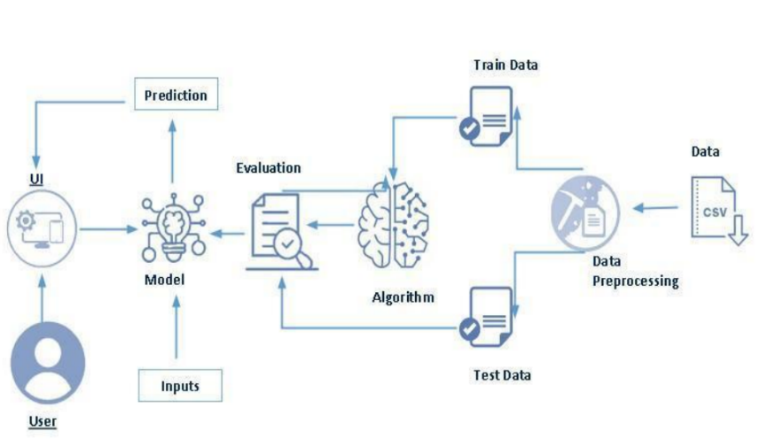

*Figure 1: Architecture and data flow of the Disease Prediction using Machine Learning*